**Spatial and Temporal Distribution of Missing Incidents (in Cheshire)**

Contents:

Intro 3

Lit Review 4

Research Questions 7

Methods 8

Datasets and Data Carpentry 8

Models/Analysis 8

Limitations 8

Ethics 8

Analysis 9

Temporal Distribution (RQ 1) 9

General Trend of Weekly Calls 9

Call Origin 9

Grade 10

Response Time 11

Calls Attended 12

Final Classification 12

Sensitivity Analysis (RQ 2) 13

Spatial and Temporal Distribution (RQ 3) 14

General trend of MP across LSOAs 14

Quantile Classification 15

LISA 16

IMD (RQ 4) 17

Total count from LSOAs in each IMD decile 2015:2020 17

Mapping IMD 18

Non-Spatial Regression: Missing Rate and Deprivation Decile 18

Spatial Regression: Missing Rate and Deprivation 19

The distribution across grade, origin and response time? (4a) 19

Mental Health (RQ 5) 20

Total count from LSOAs in each Mental Health decile 20

Mapping Mental Health 21

Non-Spatial Regression; Missing Rate and Mental Health 21

Spatial Regression: Missing Rate and Mental Health 21

The distribution across grade, origin and response time? (5b) 22

Covid-19 Distribution 22

General trend of MP 22

Association with IMD (this is a maybe if the years match) 22

Association with Mental Health (this is a maybe if the years match) 22

Discussion 23

Conclusion 23

References: 24

# Intro

Aims and objectives:

This paper uses Calls for Service provided by Cheshire Police to understand the spatial and temporal patterns of missing incidents.

* The premise for this paper is two-fold;
  + Literature on missing persons has primarily focused on the qualitative aspects that hone in on the narrative of missing people in order to shape police practise (Fyfe et al., 2015; Parr and Fyfe, 2013). Yet, there is an absence of quantitative analysis which can prove essential in the understanding of missing incident trends across time and space
  + Secondly, geospatial analysis of calls for service is paramount in the safeguarding of vulnerable people by providing a decision-making tool for law enforcement, while also promoting the use of crime research

This paper focuses on how specific risks faced by missing persons can be predicted from a combination of individual characteristics and spatial-temporal analysis. The definition of ‘vulnerability’ in this paper refers to both deprivation and mental health (explained in lit review)

……..

# Lit Review

*Definition and problems with its definition*

In the UK alone, missing persons are reported every two minutes (Stevenson and Woolnough, 2013), yet there is a large amount of ambiguity that surrounds why people go missing, how they are reported, how they can be found, who the most common groups to go missing are and how police deal with the initial response (Taylor et al., 2019). Some of this confusion stems from a lack of an implicit definition of ‘missing persons’ among police and missing persons agencies. This is a result of who the power of the definition belongs to; is it the people that report them as missing or those who have chosen to go missing? The question might be operationalised by examining who the absence is a problem for, whether it’s the victim themselves or those around them (Wade, 2000). However, if missing people are viewed as simply passive victims of this labelling procedure, they can be viewed as having little independence that minimises the complex framework of missing person reports. It’s necessary to mention that the police have to respect an individual’s right to go (and stay) missing as it is not a crime to go missing.

It was only in 2017 that this definition gained some clarity which follows in the Guardianship (Missing Persons) Act 2017 (Great Britain and Ministry of Justice, 2019). It states a person is ‘missing’ if *a) the person is absent from his or her usual residence, b) the persons absent from his or her usual-day-to-day activities and c) the first or second condition is met.* These conditions lie within not knowing the persons whereabouts and their inability to make decisions relating to his or her property; if so then the management of property and financial affairs can now be dealt with by a trusted person. However, the definition can be critiqued as idealistic ignoring further implications of domestic law and disguising the methodological complications. Therefore, for the purpose of this study, Biehal’s (2003a) definition of *going missing* will conceptualise the theoretical framework. She opposes any fixed definitions and views each case as individualistic ranging from “an intentional break in contact, deliberately chosen by the missing person, to an unintentional break in contact, which is not of their choosing” (ibid, 2003, p. 2).

*Why qualitative is lacking its place in the study of missing person and what can quant add?*

Two observations can be made regarding the literature surrounding missing persons. The first being that research is sparse, and secondly research has been highly qualitative focussing on the narrative of the victims. One possibility for these absences in research for missing persons are the complications of the legal rights of adults to be free in their movements. A UK study by Biehal (2003) analysed over 2000 missing person reports and interviewed 114 people who were reported missing, they found that 70% of young people and 64% of adults had chosen to go missing. They then categorised two main groups 1) those who become lost due to mental-health related issues and 2) and those who were forced, abducted, kidnapped or kicked out from home. It is important to note that. The reasons why people go missing are complicated and tend to be individualistic, hence the study of missing persons is restricted. However, one over arching category that has been found in the study of missing persons is the link to mental health issues. UK studies following the work of Biehal (2003b) have highlighted that some of the reasons for adults who decided to go missing were due to relationship and mental health issues. Similar findings have been found in international research where life stress and escapism play a common factor in the identification of missing incidents in adults (Stevenson and Woolnough, 2013). Most research have also avoided combining criminality with the experiences of those going missing as they tend to make a small proportion of actual cases reported. However, of this small group these include attempting to avoid arrest, failure to report for bail and more general feelings of shame that result in avoidance.

One key area in the study of missing persons is the problem with repeated incident. Not only are a large proportion of reported missing incidents actually repeated missing persons, but also a specific group of repeated missing persons are those who abscond from child and family services, mental health or disability services (Tarling and Burrows, 2004)

Moving on the focus on qualitative studies and the exploration of missing person narratives as limited to the understanding of risk among missing incidents. For example, Stevenson (2017) examined the isolation of specific subgroups in the first stages of police reporting. He argued that women reported missing tend to be re-categorised into being ‘absent’ rather than ‘missing’ as a result of a male dominated police force that participate in a form of quiet activism. We can therefore use this understanding of a female narrative as an instrument that aims to grasp the importance of gendered frames that dominate the power dynamic and underlie general mobility patterns. Although this study is beneficial as it offers a nuanced learning platform about practised reality in the police force, its based of a single case study that cannot generalise these results to all missing women. One might argue that there are too many complications in the study of missing persons that do not allow for generalisability to be effectively managed in both qualitive and quantitative studies (Flyvbjerg, 2006) , however the study of missing persons could benefit from expanding to data rich methods that provide both a predictive nature in the exploration of risk factors but also in the understanding of police interaction

Expanding on the field of quantitative studies for missing persons is Sowerby et al (2017), they used contact-based data to explore the prevalence of mental disorders of missing persons and to explore types of contact with police. Through linking individual level data across police reports and mental health services they were able to draw on a statistical association between 183 missing persons and mental health, comparing the rates with those in a random community sample. They concluded that both males and females were overrepresented as perpetrators and as victims of crime, while also having increased psychiatric morbidity compared to the general community. Substance abuse disorder was the most predominant mental disorder for both males and females. Although this paper draws on difficulties surrounding the nature of missing persons, and provides a discursive platform, its use of a small sample size reduces generalisability to the thousands of cases reported every day. The failure in addressing geographical location is still present as seen in the examples of quantitative research, failing to initiate a bottom-up approach that can better introduce police into practise though the incorporation of government change at said level.

*Importance of spatial crim*

One area of criminology and social science that lacks its place in the study of missing persons is that of spatial analysis and environmental criminology. These theories state that the occurrence of criminal events can only be understood as the intersection of offenders, victims and criminal targets that occur at specific times and places. Criminality is typically an innate phenomenon that occurs as a result of biology or developmental experiences and where the prevention of crime is viewed in terms of adapting the offenders fundamental criminality through adapting behavioural changes (Wortley and Townsley, 2016). However, environmental criminology views the offender as just one part of the equation of a criminal event where the focus is on the current dynamics of crimes. The theoretical background of environmental criminology is based on three premises. Firstly, environments are criminogenic in nature, secondly the distribution of crime in space and time is non-random and lastly true crime prevention can only happen from understanding the role of these criminogenic environments. An extension of this approach is the spatial-temporal context, or crime pattern theory, which helps explain helps explain crime templates that reflect target/victim assessment and explain the activity of spaces based on routine daily activities. Additionally, its draws importance to concentration of crime in specific nodes and edges that may or may not be explained by crime generators and attractors

*Police responses to missing persons*

Newis (1999) provides an extensive summary in regards to the polices response to missing persons, with the biggest limitation addressing the pressure for control room staff to take calls within a given time period affecting the collection of relevant information being recorded. Although this review lacks temporal validity, contemporary policing still uses very similar methods of risk management even given that 38.5% of missing persons reported in 1997-1998 had been cancelled with ‘non-reason’ or ‘non-statement’, whereas only 17% of calls were returned by police (Morewitz, 2016). Why is this figure so low? Theorists have attempted to explain this through sociological, psychological and economical explanations including the breakdown of family relationships, a lack of personal motivations, poor mental health and institutional short comings (Douglas and Ney, 1998; Stevenson and Thomas, 2018; Thorsen et al., 2020). These studies have all concluded that the reasons for why people are reported missing, go beyond the comprehension of police officers. However, if control room staff face the biggest pressure in dealing with reports, one can critique a significant misunderstanding on the effect that frontline officers and calls handlers might have on missing person cases. Heap (2016) applies this concept to the call handling and management of vulnerable and repeat Anti-Social Behaviour (ASB) victims. The research consisted of conducting a trial to access the management of repeat calls across 8 police forces; findings exposed the inconsistency of call management across the nation, with some areas receiving different treatment due to how their complaints were managed. Although this could be a resource issue reflected by the rural location of police forces, it is not in the best interest to allow ASB victims who are suffering to be diminished by their geographical location. This could be applied to the call handling of missing persons where the wide variation of call management could be reflected in the differences in functionality. The gap between public perceptions and enforcement priorities is sparse and the levels of police effectiveness taken at the preliminary stage of reporting is misunderstood (Squires, 2006).

In Newis’s (2005) later works, focussed turned to the importance and position of police risk assessments in the prioritising of those missing persons most at risk; generally, this is defined by grading each call from 1 (least at risk) and 4 (most at risk). Contemporary criminology has long noted the importance of risk- based prevention, for example…. ((Farrington et al., 2012). However, this method becomes difficult in the conceptualisation of victims, one might argue that a risk based approach to missing persons excludes there position within restorative justice by diminishing their identity to a number (Maglione, 2017). Donoghue (2013) suggests that victim engagement is necessary in developing risk assessment practises and in defining professionals understanding of vulnerability. Future policy needs to move towards understanding the processes of risk management in order to understand its effect on the status of missing person reports.

What research is needed/what secondary data is available and why this a good source for my enquiry (evidence-based policing)

Traditionally, the basis of police resource management has been accumulated by reported crime statistics, however policy and literature report statistics to be inadequate and fails to consider the collective nature of non-traditional police business (College of Policing, 2015; Wilson, 2012). Additionally, due to austerity cuts to the police force there has been increased public demand on UK police service, especially for noncriminal behaviour accounting for 80-90% of calls within police and local authority (Boulton et al., 2017). It is thus incredibly important to examine factors underlying risk management to understand its effects on community engagement and policy. Therefore, by focussing on the reporting mechanisms of the police and multi-agency partners, we will be bound witness to the inconsistencies within calls for service and how they are dependent on which agency this is reported to. The variance in reporting missing persons feeds into the disparity of ineffective training within call handling.

The geographies of missing persons can help support agency response to missing persons. In the UK each case is expected to cost the police £1325-£2415 (Shalev Greene and Pakes, 2013). Some reports have aimed to assist the police procedures including. The first normative spatial profile was conducted Gibb and Woolnough (2007) which involved analysing individualistic person characteristics in the prediction of missing person experiences. Through the use of spatial profiles, they assisted in search and rescue methods used by police

Spatial behaviour profiling has helped to improve the understanding of missing person incidents. However, these type of evidence-based policing remains new in the knowledge of ‘what works’ policing. Stevenson (2013)drew on this limitation, focussing specifically on the missing experiences that are bounded by family-police interaction. They believed that for police to respond with respect to missing situations, knowledge needs to be situated within embodied evidence. For this study they adopted a case study approach interviewing 104 persons with either key agency, returned missing people, family member of returned missing people and local police officers in order to obtain more information about what is takes to track missing adults over space and time. The key finding being that both search and rescue teams, and police focus too heavily on the linear relationship of “police search being focussed on departure and destination locations, rather than journey experience, mobility and encounters” (132). They found that 46% of individuals stayed local, additionally men and women both used the natural and built environment to hide

This research has helped recognise the geographical journeys of missing persons through the involvement of effective police-family interaction. The intersectionality between research, police and agencies, missing persons and their families introduces a discursive and holistic understanding of incidents. It is therefore important to combined research with training, considering the transition to an evidenced-based agenda for policing in the last decade, is necessary in order to bridge the gap between research and action

# Research Questions

1. How has the handling of missing person calls changed from 2015-2020 over, grade, origin, response time and classification?
2. What effect do changes in origin, grade, time and classification have on the rate of missing person calls?
3. Spatially what areas are associated with missing person calls? (rural/urban dived)
4. What is the spatial association between going missing and levels of deprivation?
   1. And how do these vary grade, response time and call origin?
5. What is the spatial association between going missing and mental health?
   1. And how do these vary across grade, response time and call origin?

# Methods

## Datasets and Data Carpentry

* Calls for Service
* IMD
* Mental health
* Census (population statistics)
* LSOA/LA lookup table
* Variables Used/data manipulation

## Models/Analysis

* Time series models
* Sensitivity analysis
* Spatial Autocorrelation Maps
* Spatial Regression
* (Justify the use of each one, referring to RQs)

## Limitations

* Problems with spatial data
* Problems with MH dataset
* Problems with IMD/census
* missing person vs missing incident
* repeated calls

## Ethics

* All cleared by UoM/Cheshire police
* All data anonymised

# Analysis

### Temporal Distribution (RQ 1)

This section will look specifically at the changing nature of missing person calls from 2015:2020 and how these trends vary between grade, origin, response time and final classification. For each relationship, anova/t-tests will be run to test the strength of each relationship

##### General Trend of Weekly Calls

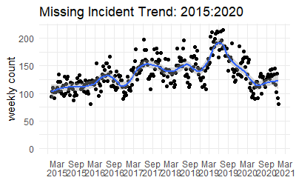

##### Call Origin

* Welch Anova Test

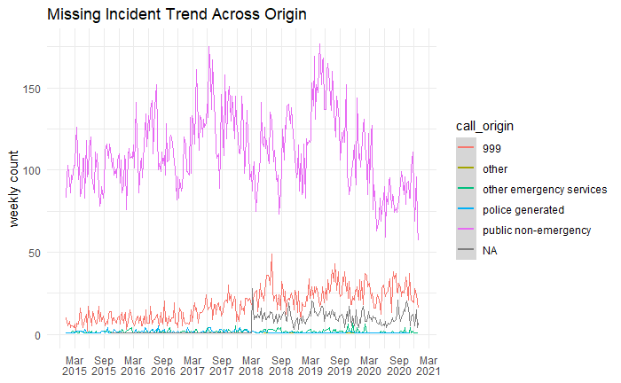

##### Grade

* Welch Anova Test

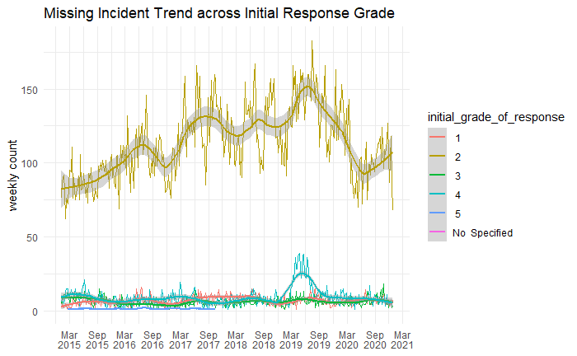

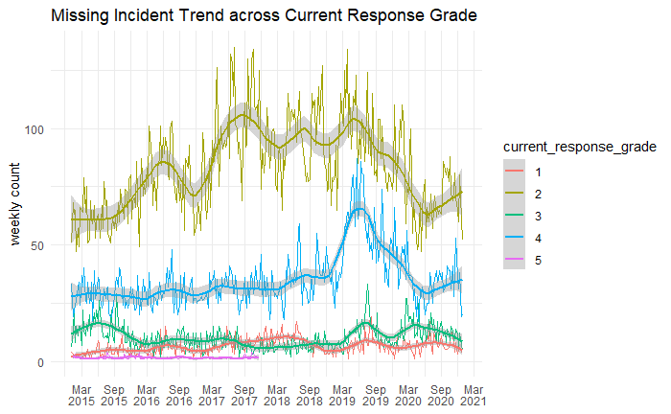

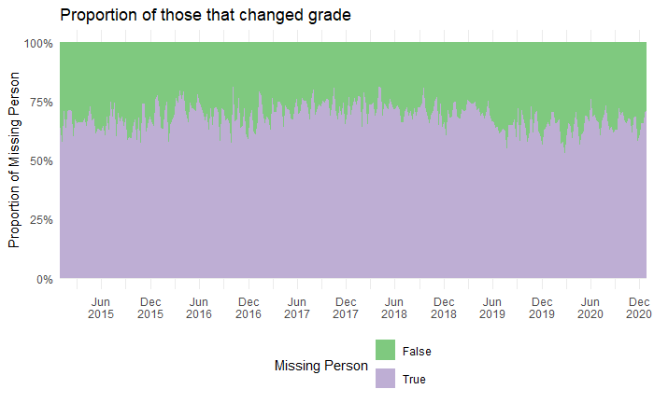

##### Response Time

* Linear regression

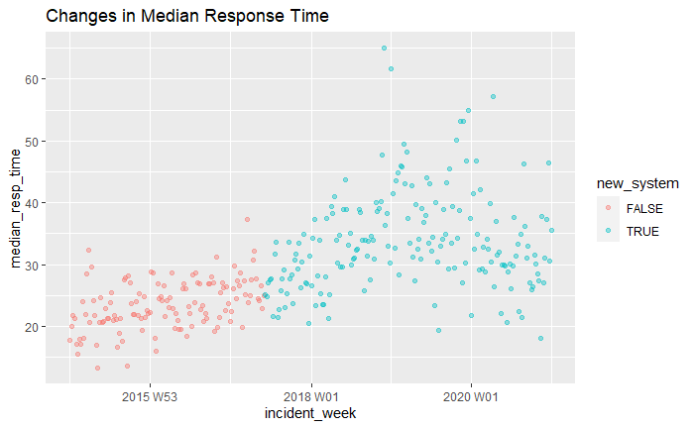

##### Calls Attended

* 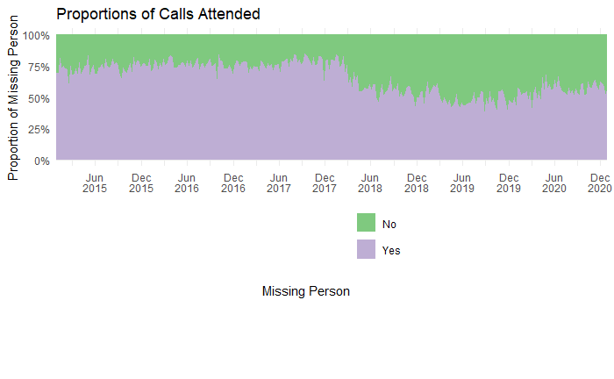T-test

##### Final Classification

* Anova

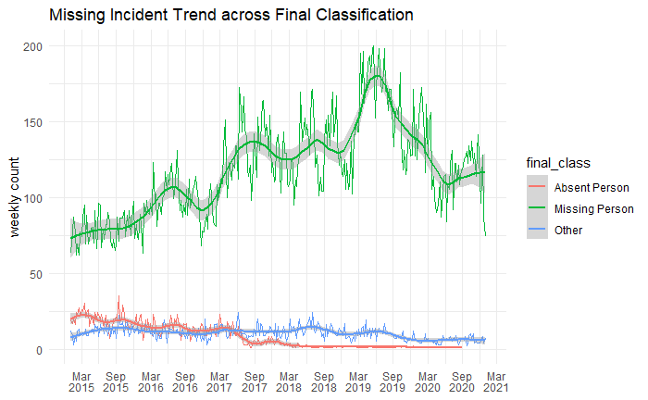

With each graph summarise and why this has led you on to study the spatial distribution

### Sensitivity Analysis (RQ 2)

In order to answer which of these predictor variables are most important or the most influential (i.e., the effect that changes in origin, grade, time, classification have on the missper rate).

A sensitively analysis will also give insight into the robustness of the population size estimates against unobserved heterogeneity (used to account for the overdispersion in Poisson Regression)

* Start with a poison regression, including interactions for unobserved confounders
* Then run the sensitivity analysis

### Spatial and Temporal Distribution (RQ 3)

* This section aims to highlight the distribution of missing incidents in Cheshire from 2015:2020
* Then to examine the spatial autocorrelation to examine whether incidents are independent of one another, and to identify clustering (or outliers)

##### General trend of MP across LSOAs

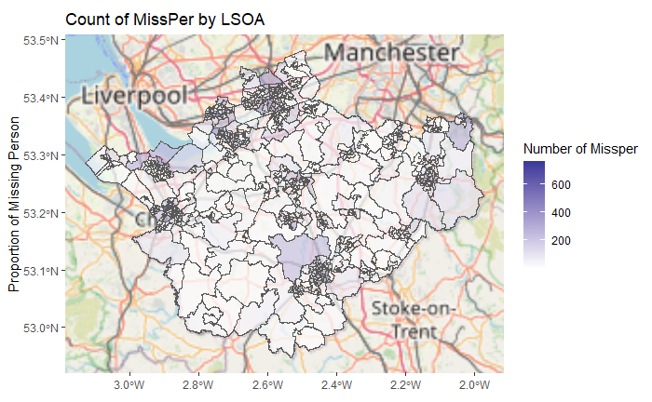

##### Quantile Classification

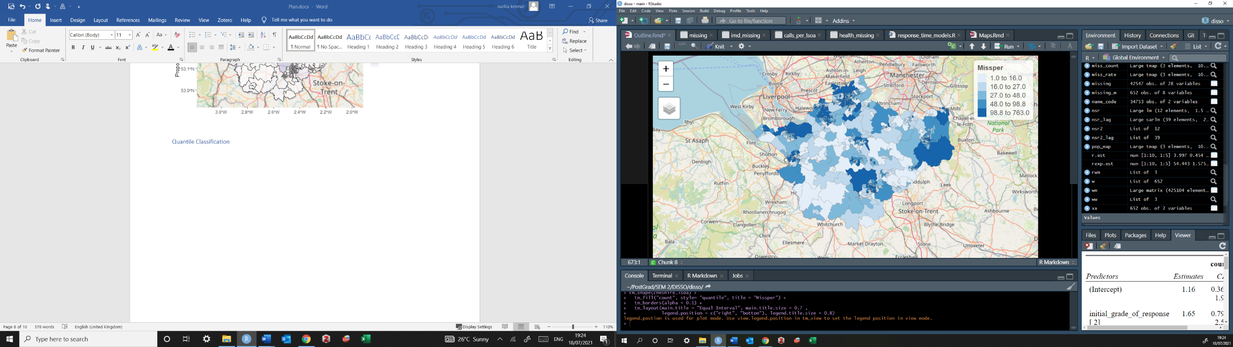

##### LISA

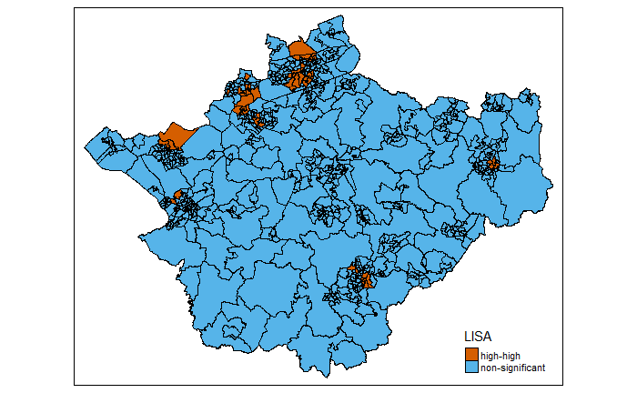

Using the queen’s criteria, created a weighted list matrix

There is a positive spatial autocorrelation. with a moran value of 0.23 and a p value of of 1e-05 we can conclude that there is indeed significant global spatial autocorrelation (the spatial processes promoting the observed pattern of values is random by chance), so what is driving this measure.

LISA map is telling us that there was some moderate clustering of mp in Cheshire

### IMD (RQ 4)

* Following the literature, vulnerability in missing incidents can be classed within levels of poverty and economic instability. Therefore, the IMD was used to explore this association through conducting a spatial regression
* Additionally, this section examines the distribution of IMD rates and the proportion of those LSOAs classed as high risk, the response time and the call origin

##### Total count from LSOAs in each IMD decile 2015:2020

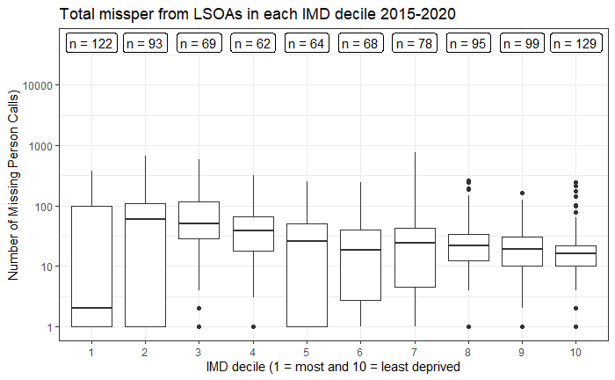

##### Mapping IMD

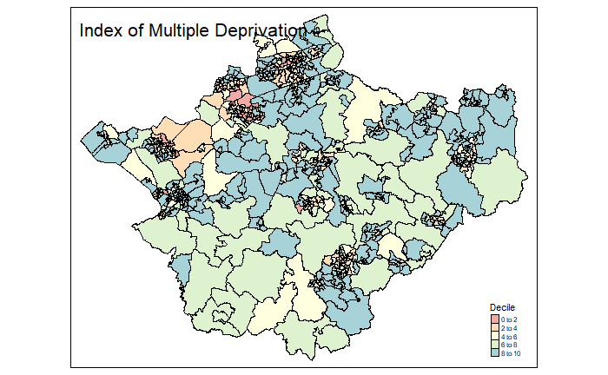

##### Non-Spatial Regression: Missing Rate and Deprivation Decile

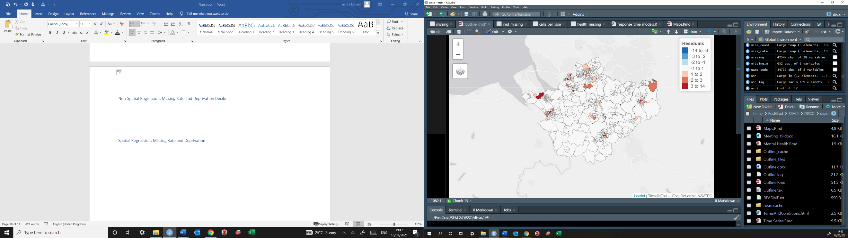

Using the morans test for regression residuals (i - 63.36, p = 2.2e-16), we obtain a statistically significant value for Moran's I so we need run a spatial regression model

##### Spatial Regression: Missing Rate and Deprivation

* RLM lag produces higher results so I will use that.
* results: the spatial lag parameter rho is significant (<2.22e-16). The AIC reduces to 85111 from 85987 (lm) therefore a better fit

##### The distribution across grade, origin and response time? (4a)

* This section will aim to show the association between differences in IMD rank and the differences in my predictor variables (origin, response time, classification etc) across LSOAS

### Mental Health (RQ 5)

* Following the literature, vulnerability in missing incidents can also be linked to mental health. Therefore, the Mental Health dataset was used to explore this association through a spatial regression
* Additionally, this section examines the distribution of Mental Health rates and the proportion of those LSOAs classed as high risk, the response time and the call origin

##### Total count from LSOAs in each Mental Health decile

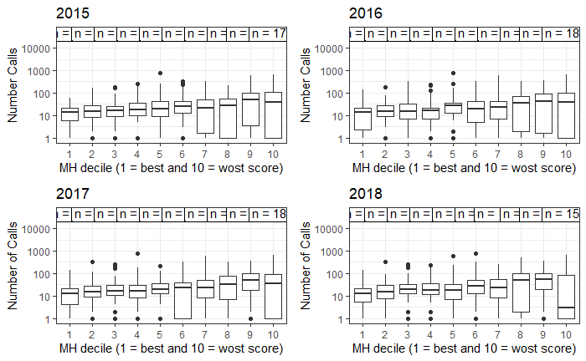

* There are more missing persons from those LSOAs with increased mental health problems (including NHS-Mental health-related hospital attendances, Prescribing data – Antidepressants, QOF - depression, and DWP - Incapacity benefit and Employment support allowance for mental illness)
* Study the means between these variances are also significant, all tests are significant

##### Mapping Mental Health

##### Non-Spatial Regression; Missing Rate and Mental Health



##### Spatial Regression: Missing Rate and Mental Health

* Again, the non-spatial regression highlights some area of over prediction and under prediction. The Morans I statistic deviate (4.2135 and p = 2.515e-05). As test is significant, we can run a spatial regression
* in order to decide to run a error or lagged model, we run a lagrange multiplier test. in this case lag is has the higher robust test so we choose this
* Again, results highlight a significant rho test, and the AIC has reduced from the linear model (12696 - 12728)

##### The distribution across grade, origin and response time? (5b)

* This section will aim to show the association between differences in Mental Health rank and the differences in my predictor variables (origin, response time, classification etc) across LSOAS

### Covid-19 Distribution

It is also important to note how these results changed during covid-19 when there was a distribution to both policing and everyday routines

##### General trend of MP

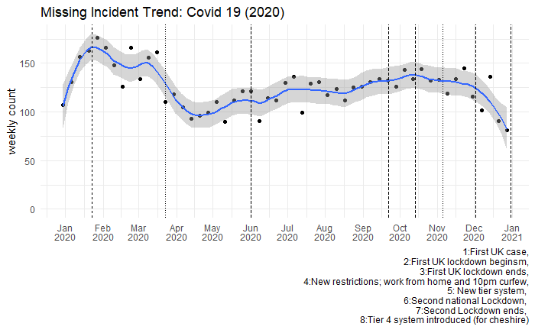

##### Association with IMD (this is a maybe if the years match)

…..

##### Association with Mental Health (this is a maybe if the years match)

…..

# Discussion

* Detail major findings and the importance
* Draw on some limitations of the findings
  + Generalisability etc
* Possibly suggestions for future research

# Conclusion

* Summarise the whole paper while restating RQs
* What contributions this paper has made
* State future directions for policy and research

Questions

1. For the covid-19 trends, would it be better to just include these in the temporal models (like we did with N8), or include these as its own separate models as seen here?
2. For the sensitivity analysis, is it correct in assuming you model these using a rate rather than the count data (i.e. missing person call rate)?
3. For the IMD, I’ve ran the results on each domain of deprivation as well (not included here?) – I think it might be more useful than just providing a holistic image – opinions?
4. I’m unsure if research question 4a and 5b truly add depth to this paper, partly because the results may not seem generalisable due to being centralised to Cheshire – I could however adda rural/urban element which may explain the changes in origin, response time and grade over the most/least deprived areas – opinions?
5. Is it possible to run a small multiple across lsoas and month, I’ve had a look and it sems there are over 600 LSOAS with more than one month of no calls reported? (And over 56 LSOAS with more than one year of no calls)
   * Following the labs from crime mapping it seems inefficient has this involves manually coding for all these LSOAS – are you aware of any other method for this?
   * Not necessary but would show a clearer trend across the months/years

# References:

Biehal, N., Mitchell, F., Wade, J., 2003a. Lost from view: missing persons in the UK. The Policy Press, Bristol, UK.

Biehal, N., Mitchell, F., Wade, J., 2003b. Lost from view Missing persons in the UK.

Biehal, N., Wade, J., 2000. Going missing from residential and foster care: Linking biographies and contexts. British Journal of Social Work 30. https://doi.org/10.1093/bjsw/30.2.211

Boulton, L., McManus, M., Metcalfe, L., Brian, D., Dawson, I., 2017. Calls for police service: Understanding the demand profile and the UK police response. The Police Journal 90, 70–85. https://doi.org/10.1177/0032258X16671032

College of Policing, 2015. Demand Analysis Report | College of Policing [WWW Document]. URL https://www.college.police.uk/About/Pages/Demand-Analysis-Report.aspx (accessed 1.12.21).

Donoghue, J., 2013. Reflections on Risk, Anti-Social Behaviour and Vulnerable/Repeat Victims. British Journal of Criminology 53, 805–823. https://doi.org/10.1093/bjc/azt023

Douglas, M., Ney, S., 1998. Missing Persons: A Critique of the Personhood in the Social Sciences. University of California Press.

Farrington, D.P., Loeber, R., Ttofi, M.M., 2012. Risk and Protective Factors for Offending [WWW Document]. The Oxford Handbook of Crime Prevention. https://doi.org/10.1093/oxfordhb/9780195398823.013.0003

Flyvbjerg, B., 2006. Five Misunderstandings About Case-Study Research. Qualitative Inquiry 12, 219–245. https://doi.org/10.1177/1077800405284363

Fyfe, N., Parr, H., Stevenson, O., Woolnough, P., 2015. ‘To the End of the World’: Space, Place, and Missing Persons Investigations. Policing 9, 275–283. https://doi.org/10.1093/police/pav025

Gibb, G., Woolnough, P., 2007. Missing persons: Understanding, planning, responding. Aberdeen: Grampian Police.

Great Britain, Ministry of Justice, 2019. Guardianship (Missing Persons) Act 2017: code of practice.

Heap, V., 2016. Putting victims first? A critique of Coalition anti-social behaviour policy. Critical Social Policy 36, 246–264. https://doi.org/10.1177/0261018315624173

Maglione, G., 2017. Embodied victims: An archaeology of the ‘ideal victim’ of restorative justice. Criminology & Criminal Justice 17, 401–417. https://doi.org/10.1177/1748895816677172

Morewitz, S.J., 2016. Handbook of Missing Persons. Springer International Publishing AG, Springer International Publishing, Springer, Cham. https://doi.org/10.1007/978-3-319-40199-7

Newiss, G., 2005. A Study of the Characteristics of Outstanding Missing Persons: Implications for the Development of Police Risk Assessment. Policing and Society 15, 212–225. https://doi.org/10.1080/10439460500071655

Newiss, G., 1999. Missing Presumed ...?: The Police Response to Missing Persons. Home Office, Policing and Reducing Crime Unit, Research, Development and Statistics Directorate.

Parr, H., Fyfe, N., 2013. Missing geographies. Progress in Human Geography 37, 615–638. https://doi.org/10.1177/0309132512465919

Shalev Greene, K., Pakes, F., 2013. The Cost of Missing Person Investigations: Implications for Current Debates. Policing 8, 27–34. https://doi.org/10.1093/police/pat036

Sowerby, A., Thomas, S.D.M., 2017. A mixed methods study of the mental health and criminal justice histories of missing persons. Police Practice and Research 18, 87–98. https://doi.org/10.1080/15614263.2016.1230062

Squires, P., 2006. New Labour and the politics of antisocial behaviour. Critical Social Policy 26, 144–168. https://doi.org/10.1177/0261018306059769

Stevenson, E., Thomas, S.D.M., 2018. A 10 year follow-up study of young people reported missing to the police for the first time in 2005. Journal of Youth Studies 21, 1361–1375. https://doi.org/10.1080/13676261.2018.1468874

Stevenson, O., Parr, H., Woolnough, P., 2017. Missing women: policing absence. Transactions of the Institute of British Geographers 42, 220–232. https://doi.org/10.1111/tran.12160

Stevenson, O., Woolnough, P., 2013. Geographies of missing people: processes, experiences and responses. https://doi.org/10.5255/UKDA-SN-851480

Tarling, R., Burrows, J., 2004. The Nature and Outcome of Going Missing: The Challenge of Developing Effective Risk Assessment Procedures. International Journal of Police Science & Management 6, 16–26. https://doi.org/10.1350/ijps.6.1.16.34459

Thorsen, C., Henry, A., Cliffordson, C., 2020. The case of a missing person? The current L2 self and the L2 Motivational Self System. International journal of bilingual education and bilingualism 23, 584–600. https://doi.org/10.1080/13670050.2017.1388356

Wilson, J.M., 2012. Articulating the dynamic police staffing challenge: An examination of supply and demand. Policing: An International Journal of Police Strategies & Management 35, 327–355. https://doi.org/10.1108/13639511211230084

Wortley, R., Townsley, M., 2016. Environmental Criminology and Crime Analysis. Routledge.